Friday, 12 February 2021
08:00 am

Location: WEBEX Video Conference Call

Attendees: Butler Smythe, Robert Publicover, Jim Fisher, Doug Cowan, Kendra Jo Grindle, Jerry Wetterskog, Charlie Hopkins, Donna Beninati, Arthur Lynn

Opening Remarks – Intros
- The CCI summary is attached for these minutes and was briefly addressed as part of items 3 & 4 of the agenda.
- Starlink Beta is operational, and info can be found online. For some this may be an interim option. It’s beta and $500 for equipment and $99/month with no data caps - for now…. Cheaper than Hughesnet/Viasat and more capacity. As an example my cost per Mb with CCI for 3Mbps = $16 (incl. bonded modem rental). Starlink at 100Mbps is about $1.
Agenda
- Town Updates – No specific activity noted, but interested in status of Stonington’s DSL expansion effort.
- Broadband Survey – Keep getting the word out & please promote the PUB site. Updates are in work – specifically to the Basics page – adding additional/specific information.
  - www.mainebroadbandcoalition.com
  - www.peninsulautility4broadband.org
- GWI and Reconnect #2 - what we know and don’t know
  - As was confirmed there is no new news from GWI and their effort which had to be resubmitted to remove RDOF areas from their application for the three towns affected through that application. They are doing this on their own dime and have been great about it! No word on timing – patience….
- CCI and FCC’s RDOF – what we know and don’t know
  - What can we do today to be ready to support either effort?
    - See the attached CCI Conversation Highlights from our last meeting.
    - Additionally from Kendra Jo… CCI (and others) are working through their awarded RDOF areas and some will be dropped (i.e. Islesboro, Cranberry Isles and others) that already have service but were included in the RDOF program.
      - RDOF is a 10-year program and the awardee needs to start work within 6 years. This will take time and some will be frustrated….
      - CCI is not ready to commit to any plan. Spring maybe?
      - Will communicate with CCI to make sure we are engaged early.
  - What can we do to add to those efforts?
    - Be Proactive! Knowing what areas of a town are CCI’s RDOF award areas, where fiber is today and the additional areas that might be combined with the RDOF work with additional community funding to affect a majority of residents. Have a plan or plans.
    - Butler Smythe noted he is starting to do that overview and provided a Draft drawing of Blue Hill - specifically noting RDOF areas, CCI fiber, RTs and Central Office and existing Spectrum areas in Blue Hill. This will be formalized and documented.
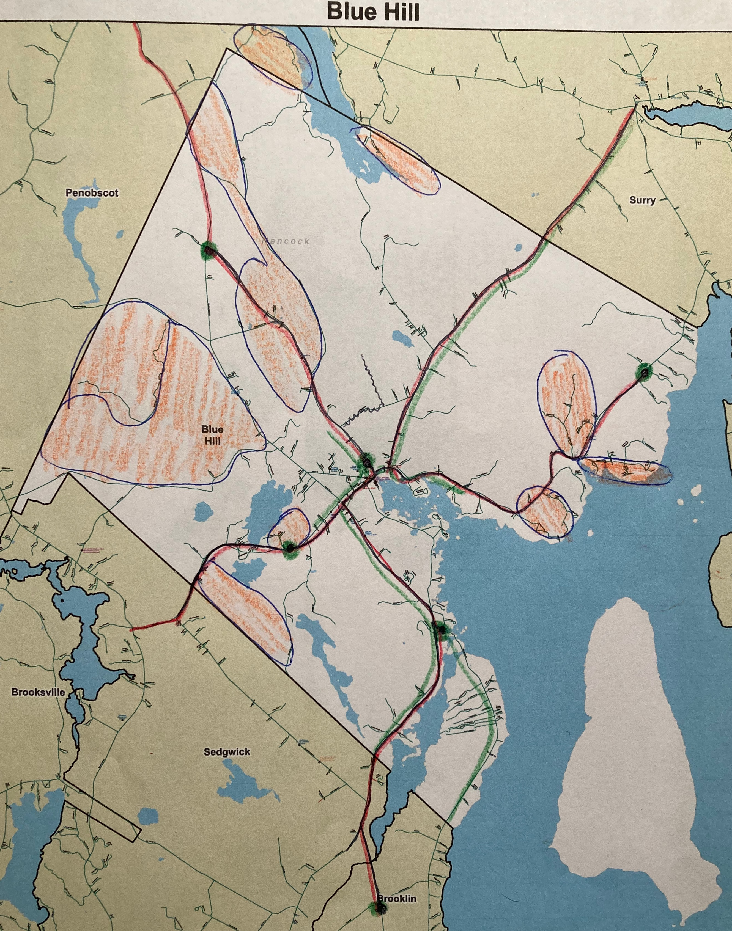
- Connect Maine Grant Program – What’s next (It’s quiet)
  - Kendra Jo Grindle confirmed that it is quiet and the committee is working through the checklist items for applications to ensure they are in compliance with their rules & baseline requirements for service. The first period may open in March but that is not set yet. Those projects ready to build would be the only ones really ready at this point.
  - Towns will need to be proactive to be ready for the second application period (timing unknown). Fall?
  - Additionally in the same discussion:
    - LD 83 under Energy, Utilities & Tech seeks to change the definition of UNSERVED in Maine to 100/100 from 25/3. Discussion noted this would conflict with the Federal definition and cause conflicts for Federal Grants, etc. and some non-fiber providers will fight it. Cable cannot meet that symmetrical service or service level. But it is the future.
- What’s next or should be?
  - Engagement – Town Engagement
    - Not all town governments have been proactive for Broadband nor support of Broadband Committees, or a larger Peninsula conversation forum like the PUB.
    - Bob and Jim have an action item below to address part of that conversation
    - Butler noted he will work to get Blue Hill more engaged
Additionally
Sarah Pebworth was not able to pass this along during the meeting so added her email here.
“I was only able to stay a few minutes anyway but wanted to let folks know that I am launching a Squeaky Wheel campaign--I'm tired of hearing all the big problems and what seem to be small solutions so I'm agitating for Bold Leadership and Adequate Resources.
I would encourage people to reach out to the chairs of the Broadband Caucus.
(The Maine Legislative Broadband Caucus is a nonpartisan, bicameral, issues-based caucus created to improve the effectiveness and reach of policy designed to bridge the digital divide in Maine by fostering a path to universal broadband and digital inclusion and equity throughout the state.)

Senator Chloe Maxmin Chloe.Maxmin@legislature.maine.gov

Senator Rick Bennett Richard.Bennett@legislature.maine.gov

Representative Tom Skolfield Thomas.Skolfield@legislature.maine.gov

Representative Seth Berry Seth.Berry@legislature.maine.gov
The caucus will be meeting every two weeks at the same time on Wednesdays, 6 to 7 PM via Zoom so 2/24 will be the next one. Legislators have been invited to let stakeholders know.
Also, please encourage the governor to show Bold Leadership and provide Adequate Resources. Janet.T.Mills@Maine.gov
Thank you for your ongoing work!
Best,
Sarah”
Action Items
      - Jim Fisher and Bob Publicover will work on an engagement plan for town governments. The goal is to have towns with both Broadband Committees and participation in a larger peninsula community group for collective discussions, agreements and hopefully paths forward.

Last Month’s Actions – Updates
- None

OTHERS
- Next Meeting – 08:00am Friday 12 March 2021 via WEBEX
  - WEBEX Invite will come out very SOON!
    - Please add link to your Notes, Calendar, etc. Invite should automatically add itself to your Google Calendar or whatever calendar you use. You should annotate your attendance from your calendar’s link.
    - Butler will have site OPEN 15-30 minutes prior to the 0800 start to work out any connectivity issues.

As previously sent:
CCI Conversation Highlights

I had a very good conversation with Jeff Nevins on 19 November and wanted to share some of the highlights – not everything - and more detail if needed at the next PUB meeting.

- CCI now has a Capital Investment partner (Searchlight Capital Partners) with a substantial interest in the company – to include $$$.
  - See: https://www.globenewswire.com/news-release/2020/09/14/2092812/0/en/Consolidated-Communications-Announces-Strategic-Investment-from-Searchlight-Capital-Partners-Initiates-Refinancing.html
  - The focus of the company and future efforts are changing
- Bottom line is that copper is going away and eventually the support for it. That includes DSL too. I’ll note that this is the first time I heard this from a “phone company” and expect to hear something like that from Spectrum in about 5-10 years. I would hope before.
- Monthly pricing levels should be close to that of Verizon Fios – at least at the 100/100 level. CCI owns the Fios location in NH (Fairpoint had it before…). It’s more than what I’m seeing from ISP’s like GWI and Pioneer Broadband but less than Premium Choice that seems to match Spectrum – or did. Makes sense on the former with no big stockholder investments driving the train.
- Specifics of location upgrades will vary and Long Island (Portland area) is getting Fiber now and the fiber to the Island is already there via Peaks Island.
- Other investments are occurring (i.e. NH and VT) – some following the Utility District type format (Hint Hint) which works well. The town backs it and cost to operate is less. Downeast Broadband Utility was the driver in getting Joel, Jonathan and I to talk about the PUB concept at an MBC meeting – too long ago. https://downeastbroadband.com.
- Backbone investment has generally been CCI (some already there I assume) and the rest the towns – for the most part. Backbone being the main town roads.
- Grants – Source of some funding but in NH and VT the towns have stepped up unlike many places in Maine. Some places just don’t get it….
- More at the meeting…

