02 August 2019
Location: Blue Hill Town Hall

Attendees:
Butler Smythe, Jim Dow, Jim Fisher, Phil Glaser, Doug Cowan, Kathleen Billings, Henry Teverow, Charlie Hopkins Mike Wolf, Stephenie MacLagan (phone), Ellen Best

Opening Remarks – Intros

Open Actions
- Henry discussion with Jim Dow (re: Treo Data – Pioneer Data Request)
  - We do not have a good handle on who has completed the data submission to Pioneer and the time that has passed from our original discussion and now may compound their agreed to effort. Blue Hill has not submitted and others may not as well. Confirmation needed for follow-up.
- Survey Information to Jim Fisher – Abbie McMillen has sent what she had to Jim Fisher. Unknown the need and follow-on use.
- GWI prep for follow-on (TBD). Simply noted there will be a lot of work that needs to be done locally should GWI successfully be awarded the loan(s) from the USDA RUS – to include the prioritization of “roads” to be served.
Agenda
- Town Updates
  - Penobscot – Joining GWI effort with Sedgwick, Brooksville and Brooklin. Submitted 95 Surveys as a part of that effort – more than enough.
  - Brooklin – Out of Town for meeting
  - Brooksville – Updated Survey database for GWI. 146 submitted and GWI needed only 20.
  - Blue Hill – Spectrum Cost ($9/foot to get service to the home beyond approx. 125 feet (or the identified distance in the Franchise agreement with Spectrum) as noted to one resident who needs $6500 to do their driveway. With 15+ years on their road and others - none still not fully served. CCI Running out of DSL lines on the East Blue Hill Road & push back at connecting homes 3 miles from CO or RT’s in several locations. Some basic service – others for Bonded service.
  - Sedgwick – No Updates (Later confirmed next meeting at Sedgwick Town Hall)
  - Stonington – Biggest concern was the efforts underway not being inclusive… Looking at working with GWI for a 3rd GWI effort with Deer Isle. The bridge appears to be a cost issue but it is unknown what thoughts on workarounds may have been made - researched or otherwise on the GWI end.
  - Isle au Haut – Currently served by a microwave tower with TDS as the provider. They are waiting to get dates for upgrades to 25/3 standard using TDS, Their committee met in the spring and were surprised by upgrades. TDS serves Matinicus, Frenchboro, Swans and Isle Au Haut.
  - Deer Isle – as noted above, and Jim agreed to look into broadening the use of their MCF funding – which has not been spent – to other areas that might include efforts that would include all towns (i.e. Neo Partners). In addition a survey was launched with 21 responses, 95% interested in fiber.
- Stephenie addressed an improved RFP Format that was initiated during work with Vinalhaven. It captures financial information that can/could be used in the short term to help define financial aspects of programs – but also for future questions that might arise. To date those types of information were not included in RFPs and could be valuable. She will share in the future. To find out more, get in touch with Stephenie or Andy Dorr (Vinalhaven) for models for municipal/coop ownership that they have explored.
  - State Broadband Conference will be 28 &29 October in Waterville at Thomas College – more information to follow and there will be space limitations. Format was briefly noted and there will be working sessions similar to the one that was held in 2018 at the same location.
    - Monday Oct 28 - Community Workshop Intensive - looking at community strategies
    - Tuesday Oct 29 - Main conference - ISPs, political leaders, advocates
  - Anticipate an invitation directly from Stephanie if she has your contact info. Invites will not go to the Google Group Address.
- Maine Community Foundation (MCF) Grant Due date is 15 October. This was passed as a reminder should anyone be able to use the funds available and that has a plan for the same.
- Henry had suggested a short list of criteria for a peninsula-wide internet system to be included as part of a peninsula-wide RFP, if needed down the road. Believe this to be a good follow-on discussion item and one worthy of thought as we should be thinking about the what–if’s should the GWI effort(s) not immediately happen.
- NeoPartners and Mapping Data was briefly discussed (see below). After some discussion Butler is to try and get an assessment from Belfast who may be the only town to use their service in Maine.
  - An email was sent by Butler (see below) prior to the meeting with a link to some data that NeoPartners provided. Rather that discussing the details it should be noted that many areas are not accurate unless some detailed research is accomplished and this may be the NeoPartners effort. In particular it was noted that Penobscot’s service providers were not correct as a result of data being pulled from a system that included parts of Blue Hill…, which included Spectrum. This is a similar problem with using and trusting FCC derived data.
- Also discussed to some degree was the connection between some vendors and VetroFiber which is based in Maine and is the developer of a mapping/design tool. https://www.vetrofibermap.com Hands on training – Live Demo (recommended to understand just what it is) is available. VETRO FiberMap is a GIS mapping and fiber management solution for broadband providers, from strategy to splice.
Vetro....
  - Detailed mapping
  - Being used by GWI, Pioneer and others
  - Need to be sure that USDA will accept this design methodology
  - Need to look at the financial modeling calibration to specific circumstance
  - Stephenie - Vetro will not produce an accurate cost estimate
    - Does not have accurate cost per pole attachment
    - Each ISP estimates a different cost per pole
    - Each pole may have a different cost
      - Attach
      - Attach other side of pole
      - Move wires to attach
      - Require a different pole
As for Downeast Broadband, they had to do an assessment of every pole (pole owner and installer). That came just prior to fiber install.

OTHERS (This is CONFIRMED)
1. Next Meeting – 0800 6 September. Location: Sedgwick Town Hall

NEO PARTNERS INFO

Attached is a shortened email from Glenn at Neo-Partners who I’ve talked to a few times over the last couple months. As partially discussed at the meeting.
As noted above there is a view below of an area that Charter “claims” is the area used in the M-Lab analysis for Penobscot… It is not correct.
Glenn got me the attached view (immediately below) to better understand why it was wrong. As noted, this is part of the FCC data puzzle and other issues with data that can be misleading unless data collection methods and areas are clarified.

The BROWN area is what they claim is Penobscot – it is not. It is apparently an area that a system (modem or otherwise) collects data from that crosses over town boundaries.
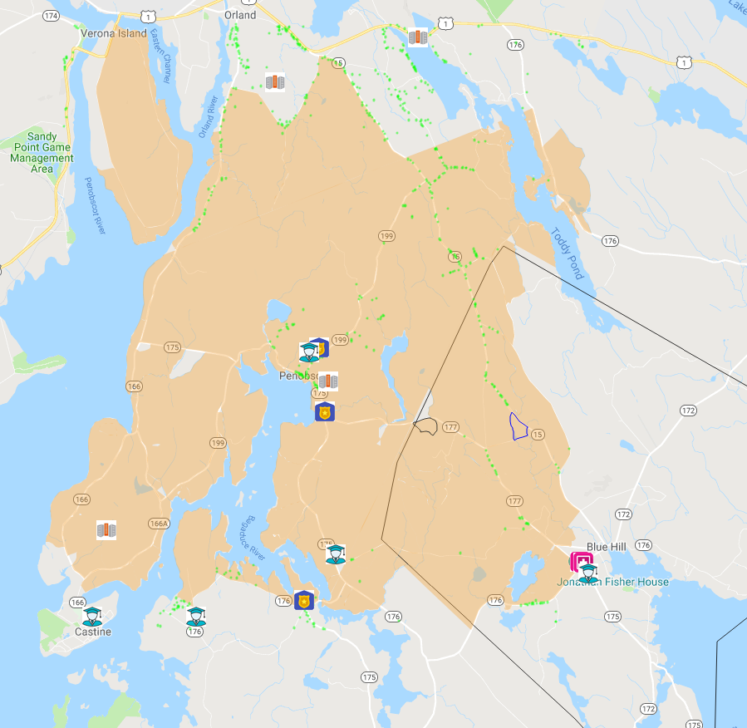

From: Glenn Fishbine <glennfish@gmail.com>
Subject: Re: Broadband QuickStart Study
Date: July 26, 2019 at 10:52:33 AM EDT
To: Butler Smythe <caerulean@me.com>
Cc: Nancy DeGidio <nadegidio@gmail.com>

For reference, we recently completed a study for Belfast, Maine. You might want to contact them to see how things went.

I've attached the draft agreement, and also I've enclosed a link that uses crowd-sourced data to give an overview of what's available in your state.

http://expressoptimizer.net/projects/Demos/USMLAB.php?state=ME&township=NO

Move your mouse over a city of interest and you'll see the available services for that city.

QUICKSTART SERVICE AGREEMENT

BETWEEN
[Community] [address]
(the “Customer”)
- AND -
Institute for Local Self-Reliance & NEO Partners, LLC 2720 E. 22nd Street, Minneapolis, MN 55406
(the “Service Provider”).
IN CONSIDERATION OF the matters described herein, the Customer and the Service Provider agree as follows:
Services Provided
1. The Customer hereby agrees to engage the Service Provider to provide the Customer with services (the “Services”) consisting of:
A preliminary call in which Customer provides Service Provider with design and budget goals and any special considerations prior to performing the analysis.
A broadband analysis of the Customer's designated community (Attachment A).
A webinar presentation to the Customer to review the content of the analysis and answer any questions.
2. Customer grants / does not grant (circle one) Service Provider with permission to use the content of Attachment A and Customer's name for its use in marketing and promotional materials.
Compensation
3. For the Services rendered by the Service Provider as required by this Agreement, the Customer will provide compensation ("Compensation") to the Service Provider as follows:
The Customer will pay the Service Provider $1,000 plus $0.40 per household within the designated area of interest based on 2016 estimated household data from the U.S. Census. Customer agrees to pay the total amount due after the completion of the webinar. The final total amount can only be determined upon receipt of Attachment B, item 1. This information may be provided prior to the execution date of this agreement, or not, at the Customer's discretion.
Term of Agreement
5. The term of this Agreement (the “Term”) will begin on the date of this Agreement and will remain in full force and effect until Service Provider receives Compensation for Services. Upon execution of the agreement, the Customer will promptly provide the material requested in Attachment B.
6. In the event that either Party wishes to terminate this Agreement, that Party will be required to provide 30 days notice to the other Party.

Capacity/Independent Contractor
8. In providing the Services under this Agreement it is expressly agreed that the Service Provider is acting as an independent contractor and not as an employee. The Service Provider and the Customer acknowledge that this Agreement does not create a partnership or joint venture between them, and is exclusively a contract for service.
Exclusion of Other Services
9. Upon the completion of the webinar presentation, and up to one hour of time to reply to follow-up questions, Service Provider has no other obligation towards the Customer under this agreement and may reasonably request a new service agreement be executed for any proposed additional services.
Governing Law
10. This agreement will be governed by the laws of the United States and by the laws of the State of Minnesota.
IN WITNESS WHEREOF the Parties have duly affixed their signatures under on this [DATE].
On behalf of the community (Customer)

:_________________________
On behalf of the service provider (Service Provider)

_________________________
Attachment A
General Content of Deliverables
- Design materials
  - Full fiber-to-the home
    - Including backbone fiber recommendation & cost
    - City & Block group detail
    - Projected fiber cost & CPE (Customer Premise Equipment) cost
  - Full fixed wireless
    - Including backbone fiber recommendation & cost
    - City & Block group detail
    - Projected fixed wireless cost & CPE cost
  - Full hybrid
    - Including backbone fiber recommendation & cost
    - City & Block group detail
    - Projected fiber cost & CPE cost
    - Projected fixed wireless cost & CPE cost
- Background documentation
- List of assumptions
- Potential internet service provider (ISP) Partners
- Explanation of recommended technologies
- Examples of comparable projects and lessons learned
- Explanation of the methodology used to arrive at projected deployment costs and reasonable project markups in actual deployments
- Discussion of budgeting, financing & grant options
- Guidance on approaching ISPs, backhaul providers, tower acquisition, community issues and other matters relevant to the community.
- An offline interactive mapping system that can be used to review each design approach down to the block group level and be shared with members of the community

Attachment B
Material Required From the Community

- Clear definition of the designated area of interest with sufficient detail to define boundaries within 10 meters.
- The 6 data items defined below, OR warm introductions to local electric utilities and/or telephone companies that service the designated area:
  - Cost per mile of installed aerial electrical and/or telephone
  - % of installed electrical and/or telephone which is aerial
  - Cost per mile of installed trenched electrical and/or telephone
  - % of installed electrical and/or telephone which is trenched
  - Cost per mile of installed bored electrical and/or telephone
  - % of installed electrical and/or telephone which is bored
- After definition of the designated area, determination of which ISPs should be included or excluded from the analysis defined in Attachment A, after the receipt of the ISP list from Service Provider.
- Answers to additional questions from Service Provider regarding items such as coverage goals, budget goals, etc.

Cost estimates provided in the broadband analysis is based upon information described in Attachment B, and are provided in accord with industry best practices. Service Provider does not control the pricing models of deployment contractors and thus cannot guarantee actual deployment costs will be the same as those provided in the Services.
The Services provided under this agreement can be expected, albeit not guaranteed, to be delivered within a few weeks of the execution date of this agreement.

